ANNUAL MAINTENANCE TRACKER
@CREATIVITY THINK (9483175986/7019689991)

ABSTRACT:
Annual Maintenance Tracker is a web-based system designed to manage, monitor, and track maintenance activities for assets in apartments, societies, and offices. The platform enables users to add assets, schedule and log maintenance tasks, record expenses, and receive timely reminders. Administrators can oversee all assets, manage maintenance schedules, track costs, and generate analytical reports through dashboards. Built using Django and Django Rest Framework for backend functionality and React with redux and recharts for frontend, the system provides a structured, efficient, and user-friendly approach to annual maintenance management..

INTRODUCTION OF THE PROJECT:
Maintaining assets in large properties or office setups often involves cumbersome manual processes that can result in missed maintenance, forgotten expenses, and inefficient record-keeping. Annual Maintenance Tracker addresses these issues by centralizing all asset and maintenance information digitally. Users can log tasks, track reminders, and monitor costs, while administrators maintain overall control, optimize schedules, and analyze operational data. The platform ensures timely maintenance, transparency, and accountability across all managed assets..

PROJECT OBJECTIVES:

• Maintain a centralized database of all assets
• Schedule, log, and track maintenance tasks efficiently
• Provide automated reminders for upcoming tasks
• Record and monitor maintenance-related expenses
• Enable administrators to manage assets, schedules, and tasks
• Generate dashboard analytics for performance insights
• Support exporting reports for auditing and record-keeping
• Ensure secure and scalable backend processing

PROBLEM OF THE STATEMENT:
Organizations, societies, and apartment complexes frequently lack a structured system to track asset maintenance and associated costs. Manual logs are prone to errors, reminders are often missed, and administrative oversight is limited. Annual Maintenance Tracker solves these problems by providing a digital, centralized, and automated system for scheduling, logging, tracking, and analyzing maintenance activities and expenses..

MOTIVATION OF THE PROJECT:
• To streamline asset maintenance management digitally
• To prevent missed maintenance tasks through automated reminders
• To track expenses accurately and transparently
• To provide users with a convenient platform for logging tasks
• To enable administrators to view comprehensive analytics
• To improve efficiency and reduce manual effort
• To generate reports for planning and decision-making

BLOCK DAIGRAM OF PROJECT:

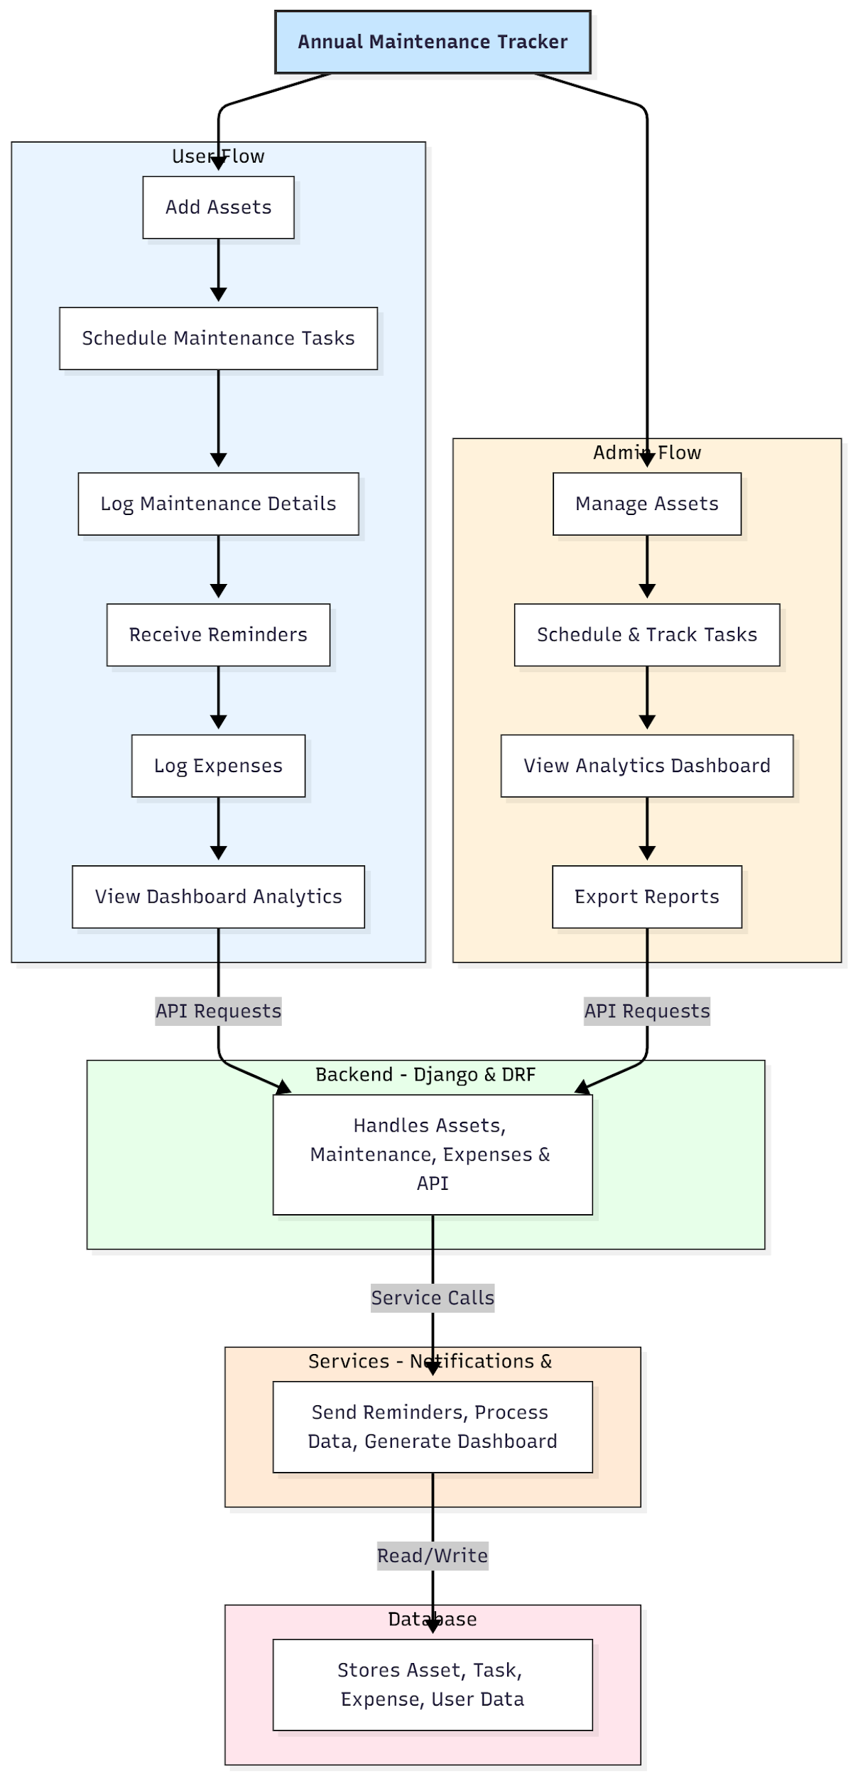

WORKING OF THE PROJECT:
Users begin by adding assets to the system along with details like type, location, and maintenance requirements. Maintenance tasks are scheduled and logged, and the system automatically sends reminders for upcoming tasks. Users can also log maintenance-related expenses, which are recorded in the database. Administrators monitor all assets, manage schedules, view analytics dashboards, and export reports. The backend validates data, updates availability and reminders, and ensures all operations are tracked securely. The services module handles notifications and analytics processing, while the database stores structured information for accurate reporting..

SOFTWARE REQUIREMENT:
- Backend:
  - Python 3.x
  - Django
  - Django REST Framework
  - SQLite/PostgreSQL
- Frontend:
  - Node.js and npm
  - React.js
  - Axios
- Development Tools:
  - Visual Studio Code
  - Postman (for testing APIs)
  - Git/GitHub (for version control)
- Server/Deployment (Optional):
  - Gunicorn, Nginx, or Heroku/AWS for hosting

ADVANTAGES OF THE PROJECT:

• Centralized asset and maintenance management
• Automated reminders for scheduled tasks
• Accurate logging of expenses
• Transparent record-keeping for users and administrators
• Dashboard analytics for performance insights
• Easy report generation for audits and planning
• Reduces manual workload and errors
• Scalable for large societies, apartments, or office setups

APPLICATIONS OF THE PROJECT:
• Apartment complexes and housing societies
• Offices and corporate facilities
• Educational institutions and labs
• Facilities management companies
• Maintenance service providers

REFERENCES:

- Django REST Framework Documentation — Django Software Foundation. Django Documentation. Available: https://docs.djangoproject.com/
- Django REST Framework. DRF Documentation. Available: https://www.django-rest-framework.org/
- React. React Official Documentation. Available: https://reactjs.org/docs/getting-started.html
- Redux. Redux Documentation. Available: https://redux.js.org/introduction/getting-started
- PostgreSQL Global Development Group. PostgreSQL Documentation. Available: https://www.postgresql.org/docs/
- MySQL. MySQL Reference Manual. Available: https://dev.mysql.com/doc/
- Git. Git Documentation. Available: https://git-scm.com/doc
- Node.js. Node.js Documentation. Available: https://nodejs.org/en/docs/
- Axios. Axios Documentation. Available: https://axios-http.com/docs/intro
- Socket.io Documentation – https://socket.io/docs/

